C++ Assignment

Q1. Write a C++ Program which prints highest number from 3 entered numbers.

// Write a C++ program which prints highest number from entered 3 numbers.

#include <iostream>

using namespace std;

int main()
{
int num1, num2, num3, biggest;

cout << "\nEnter 3 numbers: ";
cin >> num1 >> num2 >> num3;

if (num1 > num2 && num2 > num3)
{
biggest = num1;
cout << "\nBiggest number out of the three is " << biggest;
}
else if (num2 > num3)
{
biggest = num2;
cout << "\nBiggest number out of the three is " << biggest;
}
else
{
biggest = num3;
cout << "\nBiggest number out of the three is " << biggest;
}
}

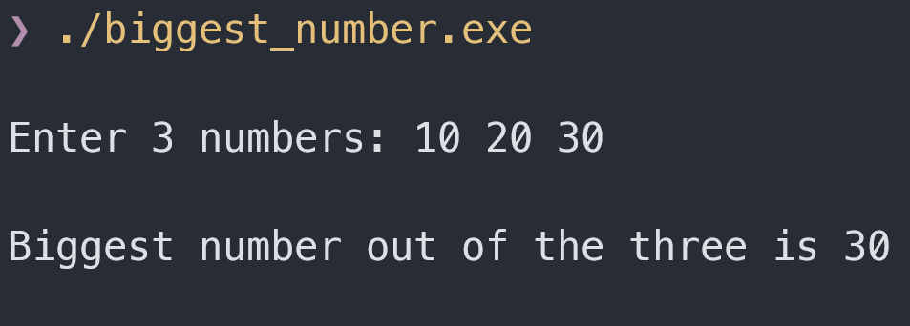

Q2. Write a C++ program to create a function named as area and find area of a triangle using no return and no parameter

// Write a C++ program to create a function named as area and find area of a triangle using no return and no parameter

#include <iostream>

using namespace std;

void area()
{
int base, height, area_of_triangle;

cout << "\nEnter base of the triangle : ";
cin >> base;
cout << "\nEnter height of the triangle : ";
cin >> height;

area_of_triangle = 0.5 * base * height;
cout << "\nArea of the triangle is " << area_of_triangle;
}

int main()
{
area();
}

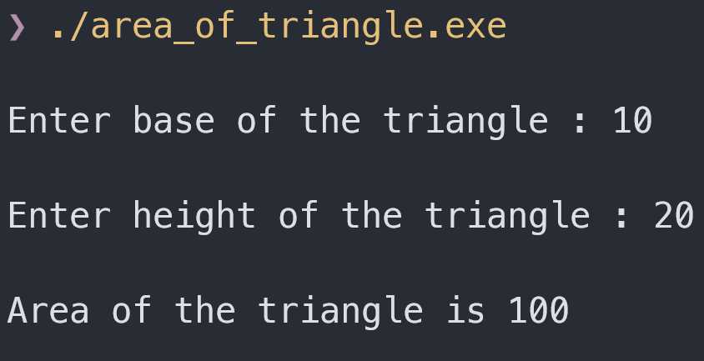

Q3. Write a C++ program to Read and Print Student Information using simple class.

// Write a C++ program to Read and Print Student Information using simple class.

#include <iostream>

using namespace std;

class Student
{
private:
string name;
int sub1, sub2, sub3, sub4, sub5, reg_no;
float total, percentage;

public:
void read()
{
cout << "\nEnter name of the student : ";
cin >> name;
cout << "\nEnter Registration Number of the student : ";
cin >> reg_no;
cout << "\nEnter marks of the student for 5 subjects [seperated by <space>] : ";
cin >> sub1 >> sub2 >> sub3 >> sub4 >> sub5;
}

void total_percentage()
{
total = sub1+sub2+sub3+sub4+sub5;
percentage = total / 500 * 100;
}

void print_info()
{
cout << "\nStudent Name : " << name;
cout << "\nRegistration Number : " << reg_no;
cout << "\n================================";
cout << "\nMarks in subject 1 : " << sub1 << "/100";
cout << "\nMarks in subject 2 : " << sub2 << "/100";
cout << "\nMarks in subject 3 : " << sub3 << "/100";
cout << "\nMarks in subject 4 : " << sub4 << "/100";
cout << "\nMarks in subject 5 : " << sub5 << "/100";
cout << "\n--------------------------------";
cout << "\nTotal Marks : " << total << "/500";
cout << "\nPercentage : " << percentage << "%";
}
};

int main()
{
class Student stu;

stu.read();
stu.total_percentage();
stu.print_info();
}

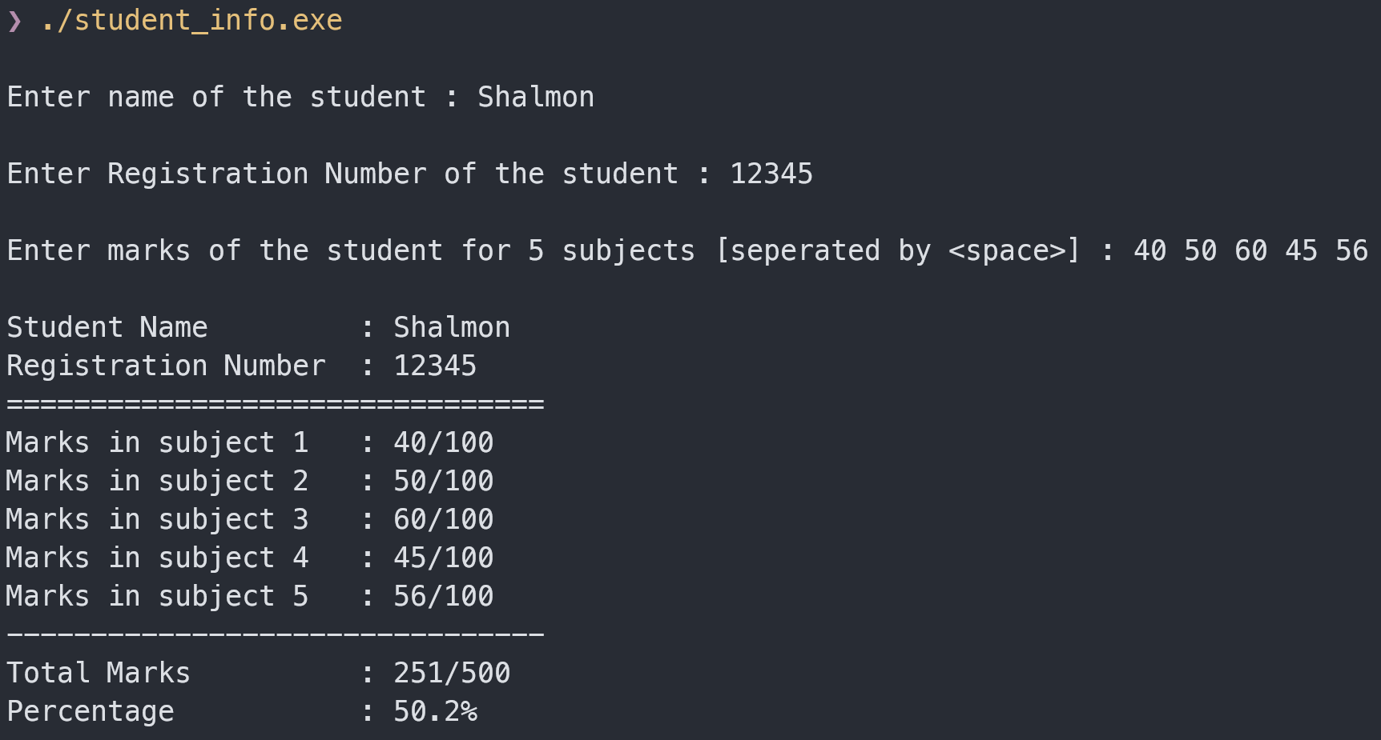

Q4. Write a C++ program to perform perimeter of a triangle and square function named perimeter() using function overloading

// Write a C++ program to perform perimeter of a triangle and square function named perimeter() using function overloading

#include <iostream>

using namespace std;

void perimeter(int a, int b, int c)
{
int peri;
peri = a + b + c;
cout << "\nPerimeter of triangle is " << peri;
}

void perimeter(int side)
{
int peri;
peri = side * 4;
cout << "\nPerimeter of Square is " << peri;
}

int main()
{
perimeter(10, 20, 30);
perimeter(10);
}

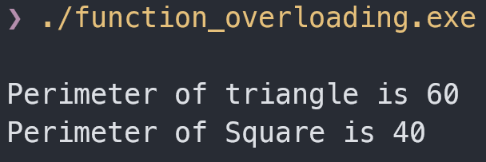

Q5. Write a C++ program for multiple inheritance

// Write a C++ program for multiple inheritance

#include <iostream>

using namespace std;

class Stu
{
public:
Stu() // constructor for Stu class
{
cout << "\nStudent name is Shalmon Anandas";
}
};

class Marks
{
public:
Marks() // contructor for Marks class
{
cout << "\nMarks gotten are 350/500";
}
};

class Result: public Stu, public Marks{};

int main()
{
Result Obj; // calling derived class, constructor gets called automatically
}

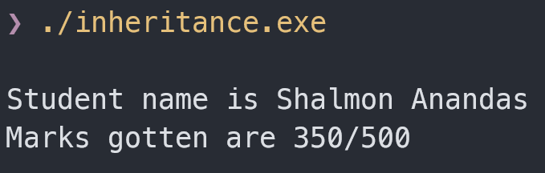

Q6. Write a c++ program to demonstrate virtual function.

// Write a c++ program to demonstrate virtual function.

#include <iostream>

using namespace std;

class Base
{
public:
virtual void print()
{
cout << "\nThis is the base class";
}
};

class Derived:public Base
{
public:
void print()
{
cout << "\nThis is the derived class";
}
};

int main() // main function
{
Base objB; // Base class called as object objB
Base* bptr; // pointer of Base class called as object bptr
Derived objD; // Derived class called as object objD

bptr = &objD; // Address of Derived class assigned to object bptr

objB.print(); // prints virtual function before runtime redefining
bptr -> print(); // prints virtual function after runtime redefining
}

